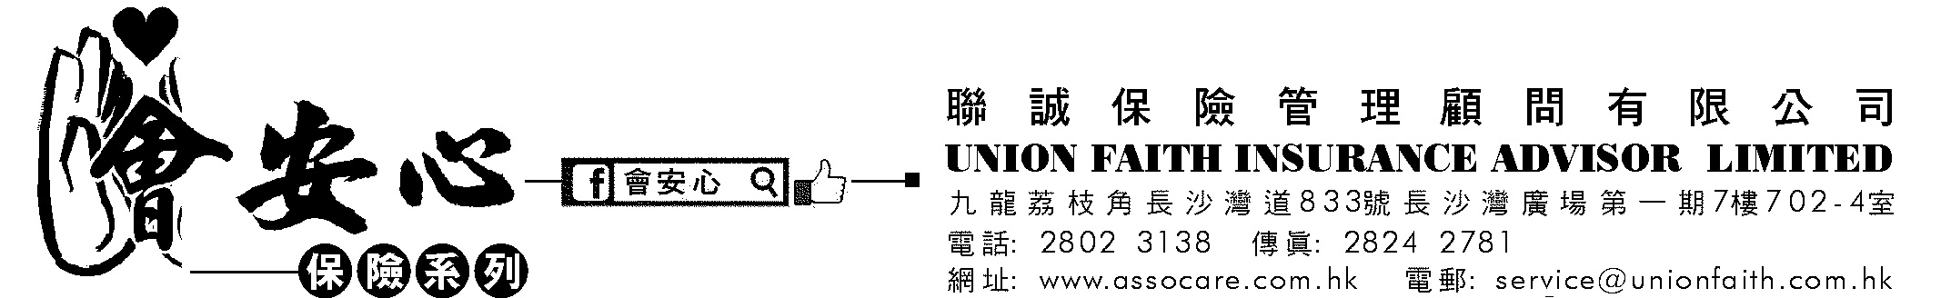

MOTOR INSURANCE AMENDMENT FORM - NO CLAIM BONUS
Procedure: 1. Please return the copy of this form by email/fax/mail/in person to us.
2. Also, if you entitle NCB, please also send together with copy of policy schedule or renewal notice which shows your NCB details.

CR-CPIC
Insured Name

Policy No.

Period of Insurance | to

Effective Date

N.C.B. | □ Delete □ Entitle
 | % N.C.B. to % N.C.B.

Email Address

Tel. No. | (Home) (Office)

Reasons for deleting/entitling NCB:

Date: ____________________ | Insured’s Signature: ____________________

Official Use Only

Premium Paid | HK$

N.C.B. | % N.C.B. to % N.C.B.

Add / Refund Premium | HK$

Date: __________________ | Signature: __________________________

